Ch 43.2 Notes

---------------------------------------------------------------------------------------------------------------------

Vocab

---------------------------------------------------------------------------------------------------------------------

Lymphocytes: Originate from stem cells in the bone marrow and then lymphocytes mature into T Cells

Thymus: An organ in the thoracic cavity above the heart

T Cells: Matured lymphocytes, also known as killer T cells

B Cells: Lymphocytes that remain and mature in the bone marrow develop as ____

Antigen: Any substance that elicits a B or T cell response

Antigen Receptor: B cell or T cell binds to an antigen, such as a bacterial or viral protein, via a protein called an ____

Epitope: The small, accessible portion of an antigen that binds to an antigen receptor

Heavy Chains: A polypeptide chain that is sticking out of the plasma membrane of a cells that hold a light chain in place

Light Chains: A polypeptide chain that is branching off of a heavy chain and is held on by a disulfide bridge

Antibody: The protein that a B cell secretes after being activated

Immunoglobulin (Ig): Another name for an antibody

Major Histocompatibility Complex (MHC) Molecule: The host protein that displays the antigen fragment on the cell surface

Antigen Presentation: The display of the antigen fragment in an exposed groove of the MHC protein

Effector Cells: Mostly short-lived cells that take effect immediately against the antigen and any pathogens producing that antigen

Memory Cells: Long-lived cells that can give rise to effector cells if the same antigen is encountered later in the animal’s life

Clonal Selection: The proliferation of a B cell or T cell into a clone of cells occurs in response to a specific antigen and to immune cell signals

Primary Immune Response: Peaks about 10–17 days after the initial exposure

Secondary Immune Response: A response that is faster (typically peaking only 2–7 days after exposure), of greater magnitude, and more prolonged

---------------------------------------------------------------------------------------------------------------------

Notes

---------------------------------------------------------------------------------------------------------------------

In adaptive immunity, receptors provide pathogen-specific recognition

* Relies on B and T cells (lymphocytes)

Anything that elicits response from B or T cell = antigen

B/T cell binds to antigen = recognition (antigen receptor)

Cells specific to their antigen

Antigen/receptors

Lymphocyte’s antigen receptors specific to antigen

Receptors bind to epitope of antigen

B/T cells are specific to one kind of epitope

Antigen recognition by B cells and antibodies

Antigen receptor

* 2 heavy chains
* 2 light chains
* Constant/variable regions

Disulfide bridge links heavy/light chains

Each receptor has two identical antigen binding sites

Receptor to antibody

B-cell receptor binds to antigen (noncovalent bonds)

Activates B cell

Secrete soluble form of receptor= antibody AKA immunoglobulin (Ig)

Igs have same structure as receptors

Lock/key

Anitgen Recognition By T-Cells

Antigen receptor has different structure

Alpha/beta chains

Disulfide bridge

Single antigen binding site

Don’t bind to epitope on antigen

Bind to fragment on antigen on antigen presenting cell

Antigen presenting cell displays fragments using proteins called MHCs

T-cell binding to APC/fragment triggers adaptive immune response

Major histocompatibility complex molecules

APC= antigen presenting cell

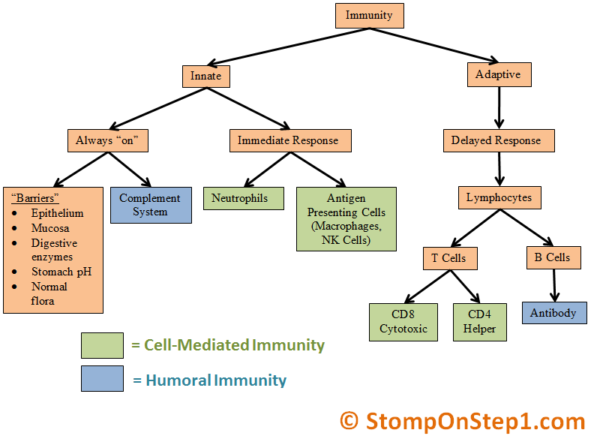

Immunological memory

Primary immune response

* 10-17 days

Secondary immune response

* 2-7 days